# Setup topo for Multicast Service

## Structure of Multicast Service

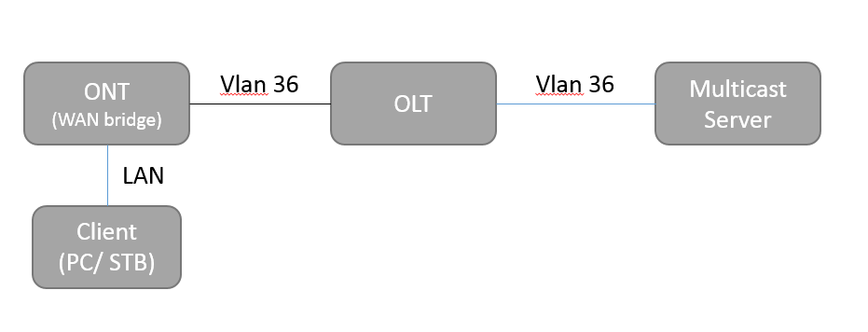

## Configure OLT

gpon

profile tcont IPTV type 2 assured 50000

!

pon

onu-profile gpon H2I1V1

tcont 1 name HSI profile HSI

tcont 2 name IPTV profile IPTV

tcont 3 name VOIP profile VOIPsss

gemport 1 name HSI tcont 1

gemport 2 name IPTV tcont 2

gemport 3 name VOIP tcont 3

remote

service HSI gemport 1 vlan 35

service IPTV gemport 2 vlan 36

service VOIP gemport 3 vlan 335

vlan port eth_0/3 mode tag vlan 36 pri 3

mvlan 36

mvlan tag eth_0/3 strip

wan 1 service internet host 1

!

!

vlan database

vlan 1,35-37,40,335,2501

vlan 3888

!

vlan 36

multicast-packet drop-unknown

!

igmp enable

igmp mvlan 36

igmp mvlan 36 work-mode snooping

igmp mvlan 36 version-mode v1 accept

igmp mvlan 36 version-mode v2 accept

igmp mvlan 36 version-mode v3 accept

igmp mvlan 36 group 239.0.0.1 to 239.0.0.3

!

interface vlan 36

ip address 36.0.0.25 255.255.255.0

!

interface gpon-olt_1/1/1

no shutdown

linktrap disable

onu 2 type DASAN sn DSNW26AFC118

onu 2 profile H2I1V1

!

interface gpon-onu_1/1/1:2

switchport mode hybrid vport 1

switchport mode hybrid vport 2

switchport mode hybrid vport 3

service-port 1 vport 1 user-vlan 35 vlan 35

service-port 2 vport 2 user-vlan 36 vlan 36

igmp fast-leave enable vport 2

iptv service start vport 2

iptv package PKG1 vport 2

## Configure Multicast Server

Open VLC media player

Click Media > Stream: Click Add and select video to stream. Then, Click Stream button

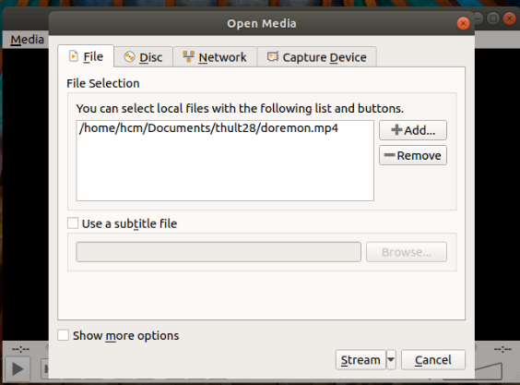

Click Next

Choose UDP (legacy)> Click Add, Input Address: 239.0.0.1

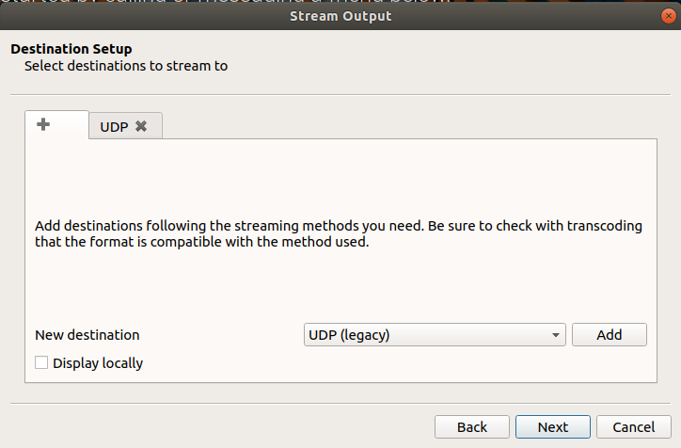

Click Next, uncheck Activate Transection, check Stream all elementary streams

Click Stream.

Noted: Change interface on linux Ubuntu 18.04 LTS, stream on interface vlan 36  
hcm@hcm-HP-280-G3-MT**:~$ ip route show  
default via 192.168.1.1 dev enp4s0**  
35.0.0.0/24 dev enp4s0.35 proto kernel scope link src 35.0.0.100   
36.0.0.0/24 dev enp4s0.36 proto kernel scope link src 36.0.0.100   
37.0.0.0/24 dev enp4s0.37 proto kernel scope link src 37.0.0.100   
69.0.0.0/24 dev enp4s0.2501 proto kernel scope link src 69.0.0.100   
169.254.0.0/16 dev enp4s0 scope link metric 1000   
172.17.0.0/16 dev docker0 proto kernel scope link src 172.17.0.1 linkdown   
172.18.0.0/16 dev docker_gwbridge proto kernel scope link src 172.18.0.1   
192.168.1.0/24 dev enp4s0 proto kernel scope link src 192.168.1.122   
hcm@hcm-HP-280-G3-MT:~$ **sudo ip route del default via 192.168.1.1**  
hcm@hcm-HP-280-G3-MT:~$ **sudo ip route add default via 36.0.0.100**  
hcm@hcm-HP-280-G3-MT:~$

## Configure ONT

Create WAN bridge with VLan is 35

## Check on Client

Open VLC and Click Media > Open network stream and input network url to view data

